Details of benefit and level of sponsorship MRS-Thailand 2017

Level/Benefit | Platinum  (100,000 Baht) | Gold  (50,000 Baht) | Silver  (30,000 Baht)
Booth | Two (3x2) | One (3x2) | One (3x2)
Waive of Registration | 4 | 2 | 2
Speaker(s) in Symposium 20 | 2 | 1 | 1
Logo on Main Stage | Yes | No | No
Logo in Website/FB | Yes | Yes | Yes
Logo in E-Abstract Book | Yes  (Back Cover) | Yes  (Inside Back Cover) | Yes
Logo in Program Book | Yes  (Back Cover) | Yes  (Inside Back Cover) | Yes
Logo on PR Board | Yes | Yes | Yes
Plaque Presentation  in Opening Ceremony | Yes | No | No
Plaque Presentation in Banquet | No | Yes | No
Certificate Presentation in Banquet | No | No | Yes

Maps & Booth Locations
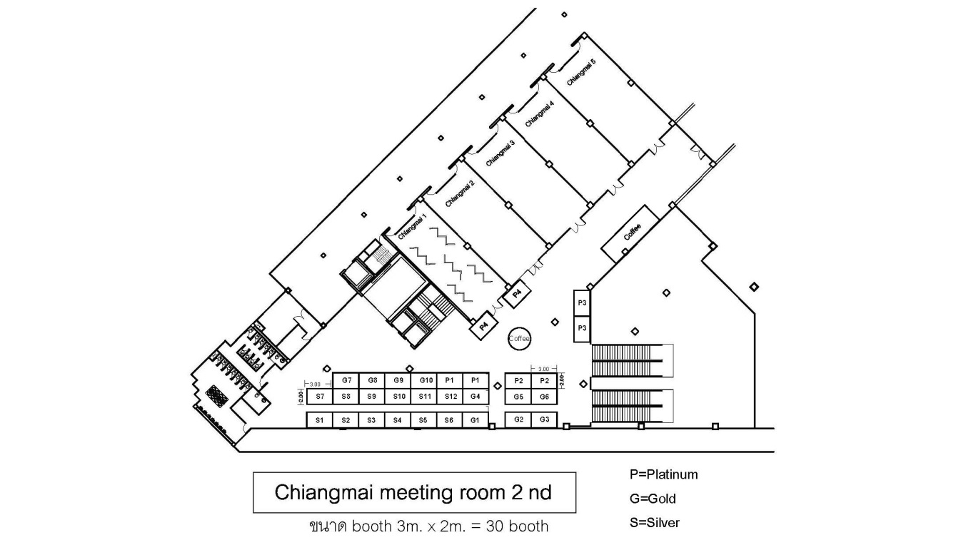
0
(Update: 4 Sep 2017)
Reserve
Available

Application form for Sponsorship
The 1st MRS Thailand Conference (MRS-Thailand 2017)

Organization .........................................................................................................................................................
Contact person.................................................................................................................................................... Tel. ................................................... E-mail .....................................................................................................
choose sponsorship package in MRS-Thailand 2017 as

Platinum Sponsor (100,000 baht) Booth No. …………………….
Gold Sponsor (50,000 baht) Booth No. ……………………………..
Silver Sponsor (30,000 baht) Booth No. ……………………………
Note: Booth position will be confirmed on a first-come, first-serve basis
attach company logo via this E-mail
require booth
give an oral presentation in Symposium 20: Material Enterprises and Industries
Number of persons who will attend this conference .................
- Name-Surname...............................................................................................................................................
Position….…………………………………………………………………………… e-mail..........................………..……….............
Organization……………………………........................................................................................................................
Tel.......................................................Mobile....................................................Fax..........................................
- Name-Surname...............................................................................................................................................
Position….…………………………………………………………………………… e-mail..........................………..……….............
Organization……………………………........................................................................................................................
Tel.......................................................Mobile....................................................Fax..........................................
- Name-Surname...............................................................................................................................................
Position….…………………………………………………………………………… e-mail..........................………..……….............
Organization……………………………........................................................................................................................
Tel.......................................................Mobile....................................................Fax..........................................
- Name-Surname...............................................................................................................................................
Position….…………………………………………………………………………… e-mail..........................………..……….............
Organization……………………………........................................................................................................................
Tel.......................................................Mobile....................................................Fax..........................................

Signature………………………………………
( )
Position...........................................
Date……….. / ………… / …….....
Bank transfer information
Account name: | MRS-Thailand Conference
Bank account: | 707-272481-0
Bank name: | Siam Commercial Bank Public Company Limited
Branch: | Suranaree University of Technology
SWIFT Code: | SICOTHBK

Please send the completed application form and proof of your payment via E-mail: 1mrsthailand2017@gmail.com. Please contact: Assoc. Prof. Kamonpan Pengpat, +66 64-3498999 or kpengpat@gmail.com for more information.

